LAB 02 IPv4 ADDRESSING AND SUBNETTING
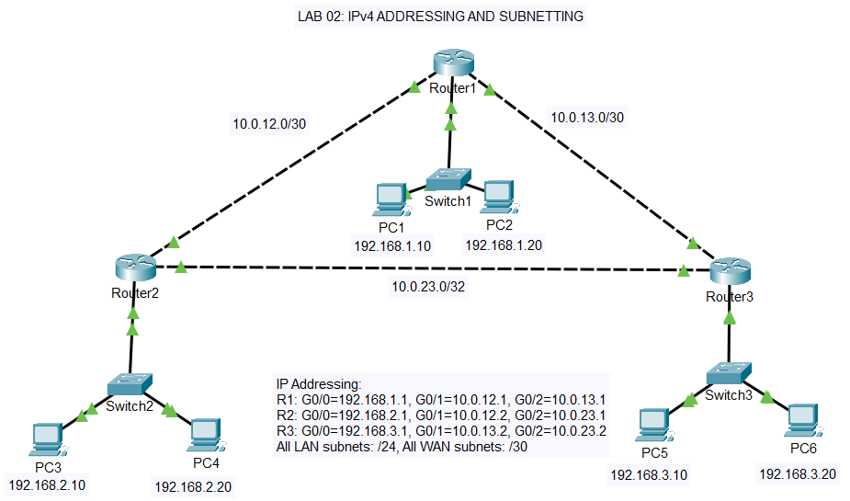

STUDENT INSTRUCTIONS
================================================================================

PART 1: CONFIGURE R1 INTERFACES
--------------------------------------------
1. Enter global configuration mode on R1
2. Configure GigabitEthernet0/0:
- IP address: 192.168.1.1 with /24 subnet mask
- Description: "LAN - Headquarters"
- Enable the interface
3. Configure GigabitEthernet0/1:
- IP address: 10.0.12.1 with /30 subnet mask
- Description: "Link to R2"
- Enable the interface
4. Configure GigabitEthernet0/2:
- IP address: 10.0.13.1 with /30 subnet mask
- Description: "Link to R3"
- Enable the interface
5. Save the configuration

PART 2: CONFIGURE R2 INTERFACES
--------------------------------------------
1. Configure GigabitEthernet0/0:
- IP address: 192.168.2.1/24
- Description: "LAN - Branch2"
- Enable the interface
2. Configure GigabitEthernet0/1:
- IP address: 10.0.12.2/30
- Description: "Link to R1"
- Enable the interface
3. Configure GigabitEthernet0/2:
- IP address: 10.0.23.1/30
- Description: "Link to R3"
- Enable the interface
4. Save the configuration

PART 3: CONFIGURE R3 INTERFACES
--------------------------------------------
1. Configure GigabitEthernet0/0:
- IP address: 192.168.3.1/24
- Description: "LAN - Branch3"
- Enable the interface
2. Configure GigabitEthernet0/1:
- IP address: 10.0.13.2/30
- Description: "Link to R1"
- Enable the interface
3. Configure GigabitEthernet0/2:
- IP address: 10.0.23.2/30
- Description: "Link to R2"
- Enable the interface
4. Save the configuration

PART 4: CONFIGURE SWITCHES
--------------------------------------
On each switch (SW1, SW2, SW3):
1. Configure the management VLAN 1 interface with IP from addressing table
2. Configure the default gateway
3. Ensure the VLAN 1 interface is enabled (no shutdown)
4. Save the configuration

PART 5: CONFIGURE PCs (5 minutes)
---------------------------------
Configure each PC with the following (from Desktop > IP Configuration):
- IP address from the addressing table
- Subnet mask: 255.255.255.0
- Default gateway: The router's LAN interface IP

PART 6: CONFIGURE STATIC ROUTES
--------------------------------------------
On R1:
- Add route to 192.168.2.0/24 via 10.0.12.2
- Add route to 192.168.3.0/24 via 10.0.13.2

On R2:
- Add route to 192.168.1.0/24 via 10.0.12.1
- Add route to 192.168.3.0/24 via 10.0.23.2

On R3:
- Add route to 192.168.1.0/24 via 10.0.13.1
- Add route to 192.168.2.0/24 via 10.0.23.1

PART 7: VERIFICATION
---------------------------------
1. On each router, verify all interfaces are up/up using "show ip interface brief"
2. Verify IP addresses are correctly assigned using "show running-config"
3. View the routing table on each router using "show ip route"
4. From PC1, ping all other PCs (PC2, PC3, PC4, PC5, PC6)
5. From R1, use traceroute to 192.168.3.10 to see the path
6. Telnet from R1 to R2 and R3
7. Document which routes appear as "C" (connected) vs "S" (static)

VERIFICATION COMMANDS
================================================================================

Router Commands:
----------------
show ip interface brief - Quick view of all interfaces and status
show interfaces G0/0 - Detailed interface information
show ip route - View routing table
show running-config - View current configuration
ping 192.168.x.x - Test connectivity
traceroute 192.168.x.x - Trace path to destination
telnet 10.x.x.x

ASSESSMENT QUESTIONS
================================================================================

1. A /30 subnet mask provides how many usable host addresses?
a) 30
b) 4
c) 2
d) 6

Answer:

2. What is 192.168.1.0/24 in dotted decimal subnet mask notation?
a) 255.255.255.128
b) 255.255.255.0
c) 255.255.0.0
d) 255.255.255.252

Answer:

3. Which device is responsible for forwarding packets between different subnets?
a) Hub
b) Switch
c) Router
d) Access Point

Answer:

4. What is the broadcast address for network 192.168.2.0/24?
a) 192.168.2.0
b) 192.168.2.1
c) 192.168.2.254
d) 192.168.2.255

Answer:

5. Why do we use /30 subnets for point-to-point links between routers?
a) They provide more security
b) They conserve IP addresses - only 2 hosts needed
c) They are faster than /24 subnets
d) They are required by GigabitEthernet interfaces

Answer:

6. In the routing table, what does "C" indicate?
a) Configured route
b) Connected route (directly attached network)
c) Cached route
d) Candidate route

Answer:

7. What is the network address for IP 192.168.1.100 with mask 255.255.255.0?
a) 192.168.1.100
b) 192.168.1.0
c) 192.168.0.0
d) 192.168.1.255

Answer:

8. Which private IP address range does 192.168.x.x belong to?
a) Class A private (10.0.0.0/8)
b) Class B private (172.16.0.0/12)
c) Class C private (192.168.0.0/16)
d) Not a private address

Answer:

